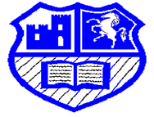 Stay Safe 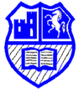
In Otford Primary we:
- Keep the doors and gates shut so that strangers do not come in
- Follow grown-ups’ instructions in any emergency (fire alarm/evacuation)
- Tell an adult if anybody around us is sad or unhappy or in danger
- Make sure registers are taken so that we know who is in the building
- Make sure our teacher sees the adult collecting us at home-time
- Make sure that grown-ups are on duty before and after school as well as at playtimes
- Include everybody so that no one feels left out
- Do not enter rooms unless there is an adult there
- Make sure that visitors wear ‘Visitor’ stickers and that they sign in at the office
- Ask an adult if we need to go somewhere
- Do not speak to people we don’t know unless they have a badge/sticker or are with an adult we recognise
- Only use the computer with an adult and only use safe websites
- Do not share personal information online or with strangers
- Hand in any medicines to the office
- See a First Aider if we are injured, ill or bump our head
- Behave safely and are kind to each other with our actions and words
- Only eat our own food/lunch in case others have allergies
- Will let parents/carers know of anything important that happens at school
- Use equipment safely and are respectful to nature and our environment
- Look after each other and report anything unsafe or anything that worries us to an adult
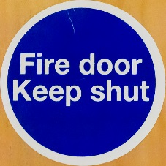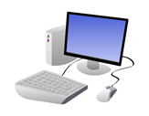
I I am worried about something and I need to talk to you…….
Otford Primary School
VISITOR


